The Earth-Shattering News About Mammals:
An exhibition by Kathleen Patitsas
Official opening Friday 7th of November 2025 at 7:00pm (doors open 6pm)
By Dr Sophie “Topa” Petit, Associate Professor in Wildlife Ecology,
Uni SA, STEM
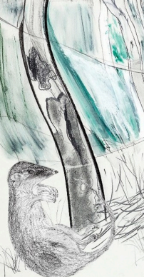
Where: Minor Works Building Community Centre, 22 Stamford Court, Adelaide
When: 5/11/25 to 25/2/26 (note: the Centre will be closed 15 Dec-2 Jan) Mon-Fri 9am-5pm (please check availability of the gallery prior to arrival, on 82037801)
Abstract: As a long-time member of the Field Naturalists Society of SA and its Mammal Club, Kathleen has spent over a decade exploring South Australia's remarkable native mammals—more than a quarter of which have vanished since human arrival. These pre-Anthropocene landscapes are exhibited in honour of Tim Flannery—whose recent theory that mammals originated in Australia has deeply inspired her—and of her mentor, Graham Medlin, a FNSSA Conservation medallist, who continues to uncover their hidden histories.
Kathleen will be hosting art workshops over the summer in the exhibition space. Details to be announced.
Visitors are warmly invited to attend this FREE event
For further information visit: <mwbcc@cityofadelaide.com.au>
Antechinus association (detail): print on paper. Photograph by John Nieddu
-----------------------------------------------------------------------------------------------------

